Welcome to Timebanking

What is Timebanking?
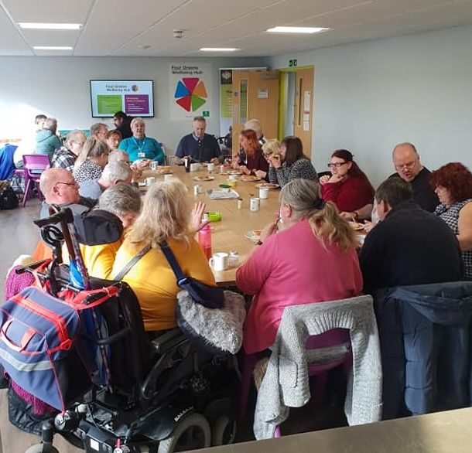
- Timebanking is a reciprocal exchange of everyday skills where the only currency is time. It is informal and flexible and fits around your lifestyle and time.

- You only offer what you want to offer when you want to do it.

- For every hour of help you give you will receive an hour in return to ask for something you want or need, from any timebank participant.

- Timebankers offer all sorts of skills such as gardening, baking, languages, dog walking, hobbies, music tuition, friendship, crafts, DIY, computer help and more.

What’s good about Timebanking?
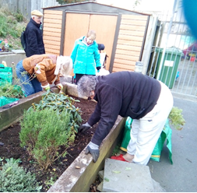
- It’s a great way to meet new people and make new friendships.

- Sharing your skills, hobbies and knowhow with others, makes everyone feel good.

- You, your time and your skills are celebrated and valued.

- You can learn new skills to add to your CV.

- It can improve your wellbeing by having fun, getting active in mind and body and spending time with other people.

- It’s free to join and no money ever changes hands.

How you can get involved
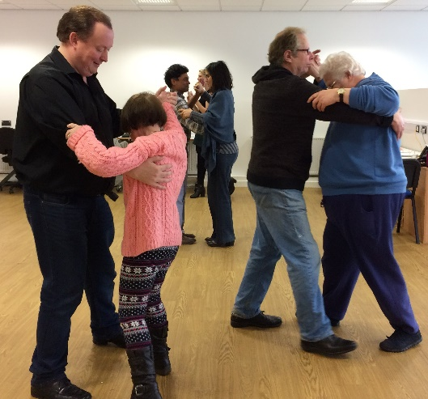
- You can attend any of our weekly socials and group activities.

- You can exchange your time, skills, hobbies and knowhow with others.

- You can ask others to share their time, skills and knowhow with you.

What we do
- We aim to reduce loneliness and social isolation and improve people’s well-being through Timebanking.

- We connect people to exchange their time and skills and we do all the arranging between those involved to ensure exchanges are safe.

- We host weekly socials to bring people together.

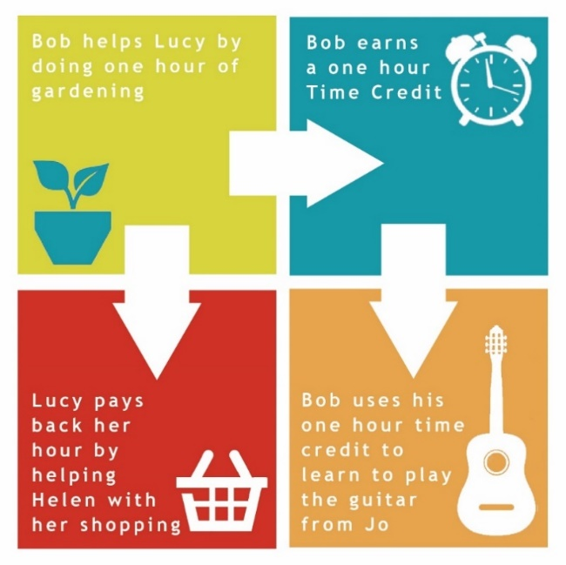
What next……
- Whenever you want to exchange your time and skill, or you want someone else to share their time and skill with you, just contact us and we will make it happen!

- Call us: 01752 875930

- Email us: info@timebanksw.org

- Facebook us: Timebank South West

- Pop-in or write to us at:
Timebank South West
15, Whitleigh Green,
Whitleigh, Plymouth, PL54DD

Timebank South West is a registered charity: 1169627

